BSC 3 Final Report

# Introduction

## Overview

For our project we decided to make a gifting system, using html, php and SQL. The aim of our project was to emulate a sort of system that enables users to login and join groups. They have he option to add to their wish-list and add users’ interests and being able to view or remove interesting. Essential the main goal of the website is to be able to look for items which will link you to a website to buy it so you can gift it to the people in your group or a friend based on his/her interest.

## Project specification

**BSc Group 3: Roma Hannaway, John Ugwu, Patrick Doherty, Derek Lee Doherty, Jack Mahon**.

The type of artefact that will be developed will be a Gift generator system. It was chosen over the other proposals based on having more pros than the others. It is going to be a more usable system for the users to interact with. We decided as a group that it was best suited to our skill sets and would be a good detailed system to make. Comparing it with the other ideas, this system would be more practical and best suited to our individual skills and we feel that we understand the systems functionality.

This system will be a development of a web-based Gift generator system. A user(s) will use the system to view different gifts by set categories. The selected categories are based off one online shop called Arnotts. The user can make a wish list and add or remove selected items on their list. The website will allow the creation of multiple users. In the system, each user will have basic information stored such as their hobbies/interests/wish list. Therefore, their followers can see what they are interested in if they are preparing to buy them a gift. Each member can create a group and add members to their group. When a member wishes to buy something, they will be sent to that specific link on Arnotts to buy the item. The outcome for the users will help them through the busy periods like Christmas or any special occasion. The project will have a recording mechanism that will record data in the database to be displayed in the webpage. The database will register the user as well and store their details to verify login. It will also store group details.

The skills that will be intended to be required is mainly problem solving as part of a team. We will use what we have learnt over the past three years in college and develop our programming skills along with working with a database server. Also, we would like to find out our strengths and weaknesses of each member to develop a strong relationship throughout the 12-week project. We intend to extend our knowledge of Java programming along with HTML code for the website. We also intend to meet on a weekly basis outside class hours to discuss what is required for each week.

Some of the specific functions would be: create account, create group, add hobbies/interests, add wish list, view wish list and send user to specific link to buy gift. The system will be useful for user who are struggling to find items to buy in local shops or aren’t sure what to buy for a specific person. On various special occasions throughout the year, specific categories will have special deals.

The software environment consists of writing in a JavaScript/ HTML/PHP program connecting with a MySQL database server. The reason we decided to use this is because in the past we have used MySQL with a JavaScript/HTML/PHP program to develop a simple system. Our system will have a GUI to allow the user to navigate easily. We will be using several resources within the college such as our existing software in the computer labs and various websites that help us throughout the process.

**Deliverable 1:** Draft Specification 2 in local shops or aren’t sure what to buy for a specific person. On various special occasions throughout the year, specific categories will have special deals. The software environment consists of writing in a java/ html/php program connecting with a MySQL database server. The reason we decided to use this is because in the past we have used MySQL with a java/html/php program to develop a simple system. Our system will have a GUI to allow the user to navigate easily. We will be using several resources within the college such as our existing software in the computer labs and various websites that help us throughout the process.

## Reference

As a team we divided the work and as previously mentioned we decided to use SQL, HTML and PHP. We gained inspiration from many websites in relation to design. Such as wedding invitation websites, Amazon and Secret Santa. Our main source of resource was using w3schools for help and for our bootstrap. Other sources would be stackoverflow for when we have errors and of course helping each other out when error or problem occurs. We also used github as a main host for all the codes we will use to implement the system.

## Conclusion

In conclusion, we believe the deliverable was a success and the project itself was faced with changes but overall had the initial plans of the system.

## Roles

**Roma Hannaway:**  Populated categoryPage and linked each of the products to the website to purchase them. Student also worked on Use Case descriptions.

**John Ugwu:** Worked on HTML of the home page, category page and Wish-list page as well as help the group members with problems or concerns group member had. Worked on the Sequence Diagram, updated class diagram and Story Board.

**Patrick Doherty:** Worked mostly on perfecting and fixing up the createGroup and Group page. Student also worked the initial Sequence diagram, updated Use Case Diagram and the original Database Table.

**Derek Lee Doherty:** He worked on the implementation of the profile page and the html of the login and register page. Worked on Behavioural State for registering a user.

**Jack Mahon**: Worked mostly on the database and implementation of the login page. As well as the category page. Worked on the first Behavioural State, Sequence diagram and an Updated Class Diagram.

(Refer to File Exchange)

# Application Design

## Major Tasks

**Roma Hannaway:**  Category page.

**Time spent**: 20 hours a week.

With the assistance of Patrick.

**John Ugwu:**  Final Report Write up, HTML Design and Assistance.

**Time spent:** 20 hours a week.

**Patrick Doherty:** Create Group Page and Group Page.

**Time spent:**  20 hours a week.

With the assistance of Roma.

**Derek Lee Doherty:** Profile Page.

**Time spent:** 22 hours a week.

With the assistance of John and Jack.

**Jack Mahon:** Wishlist page, setting up database, username in login/starting sessions.

**Time spent:** 30 hours a week.

With the assistance of Derek.

## Functional Requirement

* a user can register as a member
* member can login, logout of system
* member can select hobbies
* member can create a wish list
* member can create a group
* member can add selected people to a group
* member can browse different categories

Technical description of project

For the hardware, the team needed access to laptops/PCs to go online and write the application and create the website. For the software, the programming languages were JavaScript/HTML/PHP. The team used an application called Sublime, just a basic text editor. The team required a database, MySQL Workbench was used for this. To host the website online on a server, the team required XAMPP. This allowed the setup of the Apache and MySQL servers on their individual ports, so when the team wanted to access their website online it would be on the localhost. This application was gathering items off the online store Arnott’s. Access to their website online was needed.

Database Design - ERD/Class Diagram

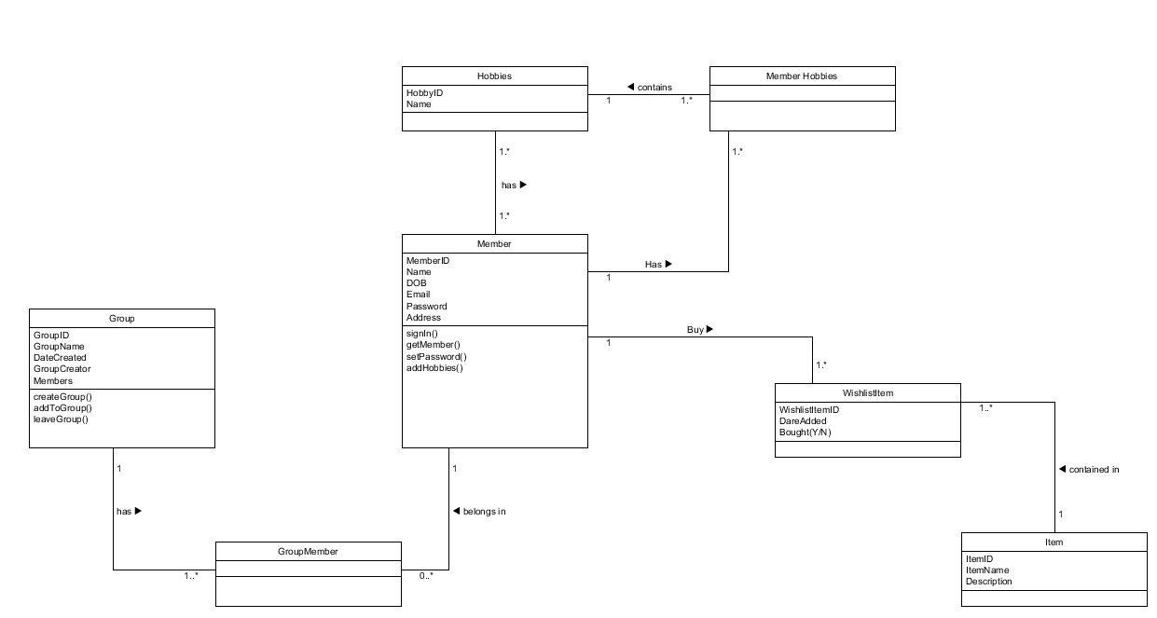

**Database tables**

|  |  |
| --- | --- |
| **Table 1** | **Member** |
| Primary Key | **MemberID** |
|  | FName |
|  | LName |
|  | Email |
|  | Password |
|  | DOB |
|  | Street |
|  | Town |
|  | County |
|  | Postcode |
|  | ItemsPurchased |
| Foreign Key | GroupID |
| Foreign Key | HobbyID |
| Foreign Key | WishlistItemID |

|  |  |
| --- | --- |
| **Table 2** | **Group** |
| Primary Key | **GroupID** |
|  | Name |
|  | DateCreated |
|  | Creator |
|  | Members |

|  |  |
| --- | --- |
| **Table 3** | **Item** |
| Primary Key | **ItemCode** |
|  | Description |
|  | Link |

|  |  |
| --- | --- |
| **Table 4** | **WishlistItem** |
| Primary Key | **WishlistItemID** |
|  | DateAdded |
|  | Bought |
| Foreign Key | ItemCode |
| Foreign Key | MemberID |

|  |  |
| --- | --- |
| **Table 5** | Hobby |
| Primary Key | **HobbyID** |
|  | Name |

## Technical Description

### Hardware:

The hardware requirements necessary to complete the task given was a functioning Hard-Drive.

### Software:

As far as software goes, we needed to have the necessary software programs for coding HTML, PHP and SQL. We needed to get a program that supports those software programming language. E.g. Sublime Text. Another somewhat software being used was GitHub as a hub where code can be stored for the group members to change and use.

### Data base Design

The ERD is a snapshot of data structures. ERD shows tables in a database and relationships between tables within database. Three basic elements are associated with the ERD and that’s Entities, Attributes and Relationships.

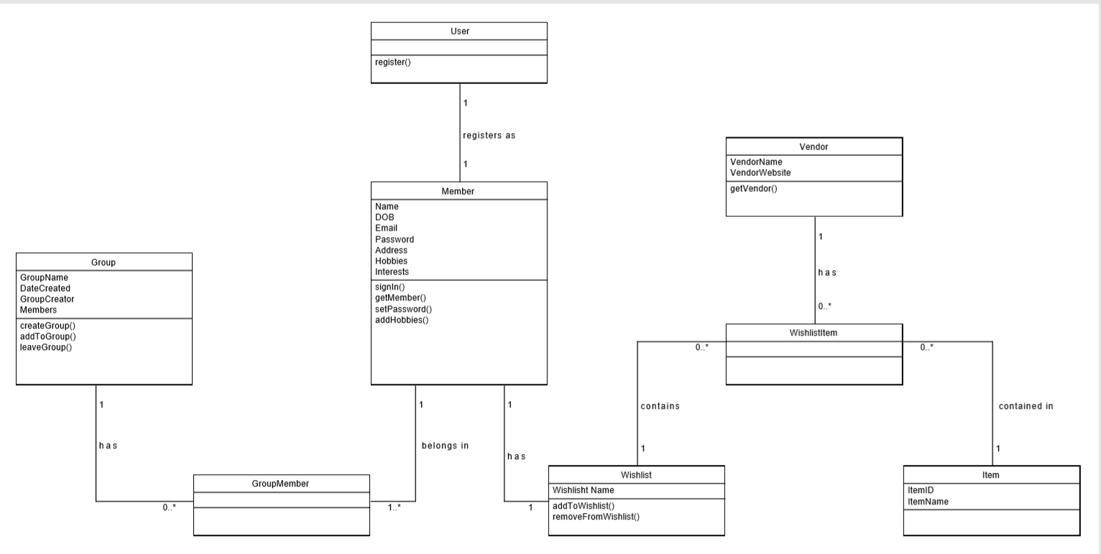

Figure 1

### Methodology (SDLC)

The Methodology used for this project was Agile, agile essentially helps teams with quick and unpredictive responses of feedback for their project. Creating the opportunities for a project during the development cycle and helps the team asses the project with regular meetings.

Its an empowering process that helps with the designing and building the right product. We choose this process because of its benefits. Agile Methodology is beneficial for Software developers due to its flexibility, it helps the team analyse and improve the product during its development.

Another reason we chose this is because of the use of the 12 principles it contains such as:

* Information best transferred between face-to-face conversation
* Sustainable development
* Reflection and adaption amongst teams for efficiency.

As previously mentioned agile brings software benefits and the most notable ones that was helpful to produce our project was:

* Allowing for change: Creating opportunity to reprioritize and refine the product.
* The focus on Business value: The team understood the importance of the product and what would give the most value for the consumers.
* Flexibility: The Scrum Methodologies allowed for a more flexibility. The team had more control in the management of work load and what needed to be done. By making continuous progress towards to final product milestone.

### Implementation Issues

When starting the Project, originally the main issue was trying to figure what the project would be and what platform we planned on using. We easily overcame that obstacle through trail and error. However, like most coding-based projects we were meet with issues. In relation to the first deliverable of the project, initially there were certain area of UML Case that the team didn’t know very well. For example, the sequence diagram was one aspect of the UML Case that those who were allocated to work on it had very little knowledge. This was a simple solution, as everyone had to go back to revise UML Cases again and teamwork and rechecking was done in the process of the first deliverable.

When it came to coding style, it was relatively easy to understand, there was no real issues when reading the group members code. Although are style was different, the styles didn’t change drastically from member to member.

Originally, when coming up with the design for the website, it was some members intention to code everything from scratch, but we later realised how tasking it was to do so, as we encountered many errors along the way. An example would be trying to centre button on the website. We decided as a group to take a much easier approach. Last year we were introduced to Boot Strap, a pre-made template for coding. We decided to use that instead to make it easier and make the task increase in a steadier pace. The template we generally gravitated to was of the bootstrap in w3schools. A very simplistic yet visually appealing bootstrap template to use.

SQL was the core language needed for the implementation of our project. We needed SQL to make tables and databases for the website. We had not done SQL since first semester of second year. So, when it came to implementing SQL into our code and using MYSQL it took awhile to remember how to implement it, so error correcting and implementation of code may have delayed the process.

# Reflections

### Activities Performed

When it comes to activities done, we first started planning meet-ups to work together on the tasks at hand or inform group members on what has been done. We also had a constant conversation via messenger to update the team on what was going on with the project.

### Individual Contribution

**Name: John Ugwu**

**L00137571**

**1. What were your major contributions?**

My major contributions for this project mainly focused on the helping group members with coding issues, I of course assisted in the storyboard of our website and the html of some of the websites but overall my focus was doing the final report and assistance of code.

**2. What do you consider you did well?**

I think my communication with the other group members were good and my attitude towards issues surrounding the project was quite positive, my ability to find a way around the issues and encourage and assist my team.

**3. What do you consider you did less well?**

Lack of individual coding, Although I did some of the use cases and html and storyboard, there came a point in the project that I had little to do. This was due to some XXAMP issues with my computer and lack there off internet in my apartment.

**4. What grade would you award the project? Why?**

I would award it 70%, my reason for this is although at point some group members were left with little to do. In the group itself attendance was consistent in most of the group, communication was good and work that was given was always done on time. Another thing to add was group work in the classes. The time we spent working was plentiful.

**5. How could the grade be improved? Justify your answer.**

Consistency, we had good communication towards the start and middle but towards the end it lacked but it didn’t affect the overall project, I feel like we had a lot of induvial work that had to be done outside the project we had as a group.

**6. What behavioural and work changes would you adopt in any future team work that you might be involved in?**

I think I must evaluate the disadvantages I faced during the team project and figure out ways in the future to prevent it. To be able to have more independency when it comes to coding for the group, instead on focusing more on assistance of code in the group. Improvement on leadership skills, learning how a good leader would organise a team project and steps needed to be taken to motivate and evaluate a project.

**Name:** Patrick Doherty

**Student Number:** L00135064

**1. What were your major contributions?**

|  |
| --- |
| My major contributions throughout the project were a number of the diagrams at the start of the project, namely the class diagram and use case diagram, as well as the use case descriptions, designing the database and create the group and create group pages, with both pages being able to pull information from the database and the create group page being able to insert new group information into the group table of the database. |

**2. What do you consider you did well?**

|  |
| --- |
| I think that I worked well with the rest of the group throughout the timeline of the project, from brainstorming what needed to be in the diagram and database to helping others in areas of code which they struggled to figure out themselves. I communicated well with the other main coder of the project and made sure my code would work in conjunction with theirs and that no errors would arise. I feel that I also integrated aspects of the database well into my code. |

**3. What do you consider you did less well?**

|  |
| --- |
| In terms of things that I did less well, one thing would be that at times I was too focused on a certain aspect of the project, which took away from expanding on other parts of the project that could have made them turn out better. There were also a few parts of pages that I could not implement fully or at all in some causes and had to make a more basic implementation or omit it. |

**4. What grade would you award the project? Why?**

|  |
| --- |
| Given the complexity of the project and the product delivered, I would award the project a grade in the region of 70% to 75%. The project would lose marks due to a few errors that exist in certain parts of the project that could not be rectified due to the time constraint on the project, but these errors do not hinder the navigation of the project and the layout of the system is slick and consistent. There are also subtle aspects to the project and simple error checking that makes the project more secure and user friendly. |

**5. How could the grade be improved? Justify your answer.**

|  |
| --- |
| As with any project, the grade could be improved by improving error checking. The tables in the database could also be a bit more coherent as there is a lot of tables and fields to be implemented and understood. The most obvious improvement would be to fix certain elements of the system that don’t work fully, such as show group details on the group page, as I could not implement it correctly. |

**6. What behavioural and work changes would you adopt in any future team work that you might be involved in?**

|  |
| --- |
| At the start of the project into the middle, there was no clear system entirely in place so in the future I would try and get a clear end goal established as soon as possible and a thorough design created so that the team knows what they are working towards and what they must do to get there. I would also separate the work out more, as at times members were working on the same thing when it might have been better to do different aspects of the project. |

**7. Any other comments.**

|  |
| --- |
| The team worked extremely well together in my opinion and if the project had been slightly less complex, then a very impressive system would have been created. |

Jack Mahon

**1.What were your major contributions?**

At the start I set up the database. As a group we sat down to discuss what tables we needed and what fields were to go in the tables. My job then was to go off and set up the database in MySQL workbench. Once this was set up, my next step was to test the database. Making sure it can create, read, update, write and delete from database. This was done by writing PHP code and SQL statements, this was done the first couple of weeks to get us started. Later in the project, my major contributions were the verifying the login, starting sessions for when the user logs in the print out their name, so it is their current session, working on Wishlist page and doing the journals.

**2. What do you consider you did well?**

I felt my main area was working with the database. I wanted to able to write and read from the database because this was planning on being an important task in our project.

**3. What do you consider you did less well?**

When I was working with the databases, I felt I was working well with it in the first 4-5 weeks of the project. However, in the last recent weeks I started to go away from the database side of it and work with the team on the html of the webpage. I consider I should have stayed where I was at and got the database more involved in the latter stages of the project.

**4.What grade would you award the project? Why?**

Out of 10 I would grade it 6. It felt like an exciting project from the beginning, and it was great working with the team to find out where are strengths and weaknesses are. However, the only reason I grade it 6 is because we didn’t achieve some of the functionality we intended on at the beginning.

**5.How could the grade be improved? Justify your answer.**

This grade could have been improved by working more on getting the functionality working from the start. I felt from the start we were working too much on the html/css side of the project instead of working on the important tasks first. We met regularly once a week, I feel meeting more than once a week could have improved this grade.

**6.What behavioural and work changes would you adopt in any future team work that you might be involved in?**

We organised to meet once a week for weekly meetings to discuss where we are at in the project. For the future if I was involved in any teamwork, I would want to have more than one meeting a week to get us more prepared.

**Roma Hannaway**

**L00137008**

**1.What were your major contributions?**

Throughout this team project, I have contributed in many ways with the team. My major contributions to the project would be helping plan up the UML diagrams at the start of the project process, as well as writing up the ‘Create Group’ Use Case description. Another major contribution I had was for the ‘Categories’ page within our website. For this page, I populated each given category with different items available for users of the system, while allowing them to have the option to either add the item to their wish list or click a viewing button that linked them directly to the webpage where the purchase of the product could be made.

**2.What do you consider you did well?**

When looking at the work I have put into the team project, I feel I worked better on the front end of the project. I found that I worked better working directly with the webpages. I also feel that as a team we worked very well together which helped with the project.

**3.What do you consider you did less well?**

For this team project, I feel I didn’t do as well with the backend of the project, containing the databases etc. and so stuck more to the front end with the design and layout of the webpages. I found it harder to link data up to the databases and so got other team members who are stronger coders than me to help with these aspects of the project as they could work better with it than me.

**4.What grade would you award the project? Why?**

Overall, I would award our project a mark of around 70%-80%. I feel we put in a good bit of work and hours both inside of class and outside of class, and we worked well together as a team to meet as many targets as possible. I feel happy with the project we have created over this semester but would deduct marks for not completing all of the functionality we originally thought we would.

**5.How could the grade be improved? Justify your answer.**

I feel the grade could be improved if we had a bit more time to work on it and put more detail into the project where needed. We had weekly meetings, but I think if we had a couple more we could have covered more within our project.

**6. What behavioural and work changes would you adopt in any future team work that you might be involved in?**

I think for any future team work I may be involved in, I would try to ensure each team member has an equal enough work load and everyone understands what they are doing and what needs done. I have taken from this that communication is key in any team, and so would adopt this and apply it where needed in the future. I would also ensure team meetings are carried out weekly.

**7.Any other comments.**

I feel we worked very well together as a team and I am happy with the project we produced together.

### Team Self-Assessment

**How were decisions made by the team?**

Decisions were made as a collective, it was a democracy, and majority vote would win. We would gather as a team in the rooms in the library or discuss amongst ourselves in the group chat or class.

* **Did all the team members contribute equally to the**

**development of the project?**

First stage of the project everyone was given a certain task, for example, A team member would be given the task to make a Use Case diagram and another one the description. Another example would be a team member having to update work previously done by the team member. Second stage, Coding stage although initially work was done equally at some point one or two members would not have much work needed to be done as someone else in the team would.

* **How much communication occurred during the project? What**

**different forms did it take?**

When it came to communication, majority of it was consistent. We had many forms of communication, from GitHub, Blackboard, Messenger, Class and Team meet ups. If one member wasn’t in, we would be informed before hand and then we would proceed to give them the instructions or changes made to the project via messenger.

* **Describe one technical problem that was overcome by the**

**team.**

One technical problem was software not working, for example, in order for the members to view and work wit our SQL and PHP we needed XXAMP to work, however it was having some issues of it working.

* **Describe one team problem that was overcome by the team.**

I think one problem was how we would distribute the work load equally to the members of the group when it came to the coding aspect of the project.

* **How does working on a team project compare to working**

**individually on a project?**

When it comes to working as a team a project is done faster than it would have been done individually. There is also room for many ideas, more people in a group the more ideas can be made for the project and assistance can be had when it comes to a problem in the project.

* **What were the strengths of the team?**

Communication I believe was our strength simply because that was our most consist skill we kept throughout the making of the project.

* **What were the weaknesses of the team?**

The weakness of the team would be basic or little knowledge of SQL.

* **On reflection after the fact, how could the team be improved**

**to improve performance and avoid problems? If you were to**

**start again what would you, as a team, change?** I think when doing a project, our resources should reflex our knowledge. As if creating a software-based project we should pay attention to our strengths when it comes to programming language. This will allow for an easy process for the creation of the project.

# Conclusion

In conclusion, the project was a success, like many projects we were faced with many obstacles, as the project progressed the more challenging it got. I believe our only weakness was the distribution of work load and our knowledge of SQL wasn’t having refined as it should be, however due to this project, it enhanced our already basic knowledge of SQL. Each member worked well with what they were given, even with little to do, the team always found ways to be of assistance.

# Appendices

## UML Diagrams

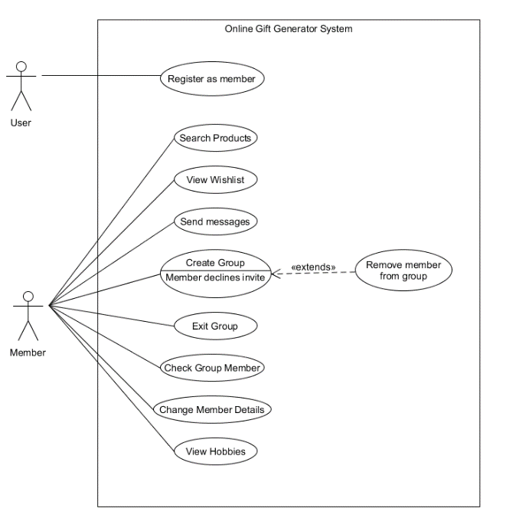

Figure 2: Use case diagram

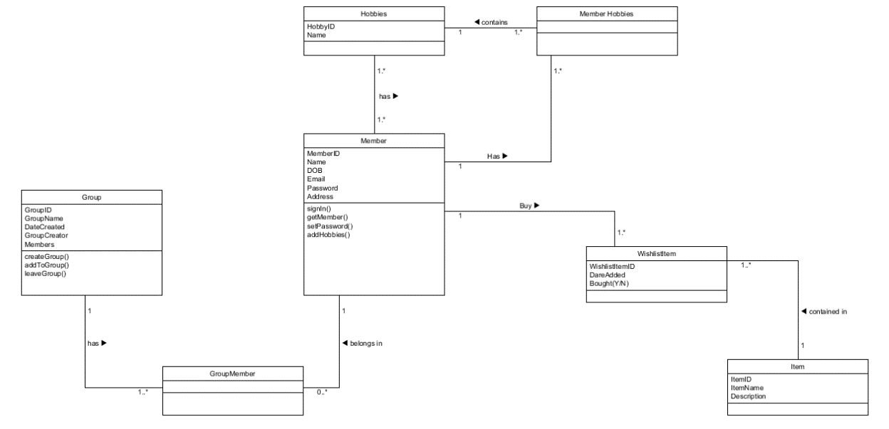

Figure 3: Class Diagram

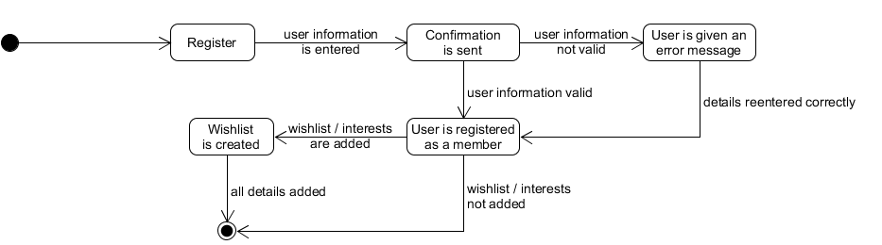

Figure 4: BS Register

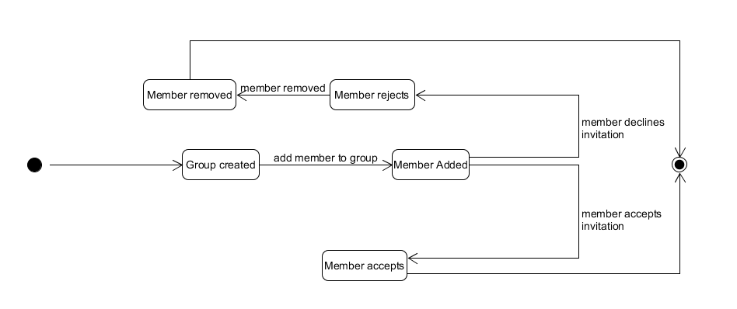

Figure 5: BS CreateGroup

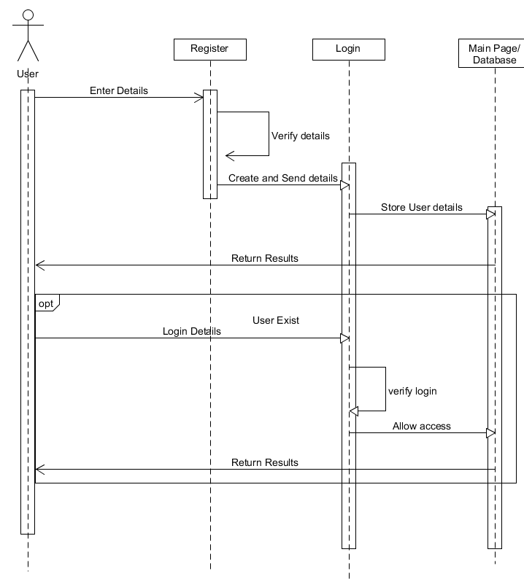

Figure 6: Sequence Register

## Journal Entire

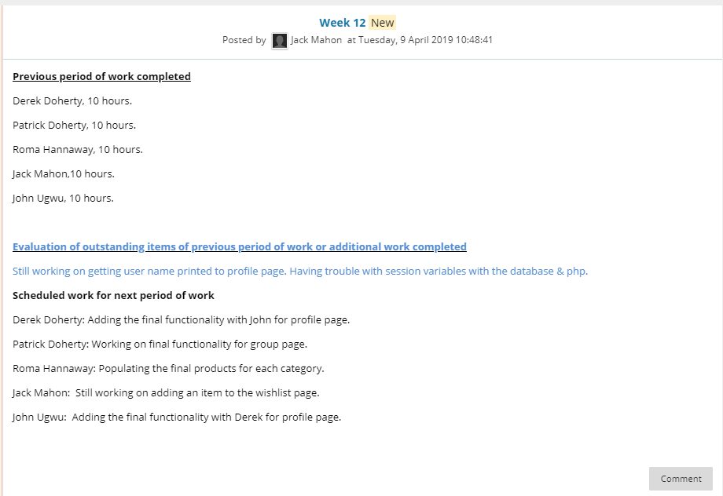

Figure

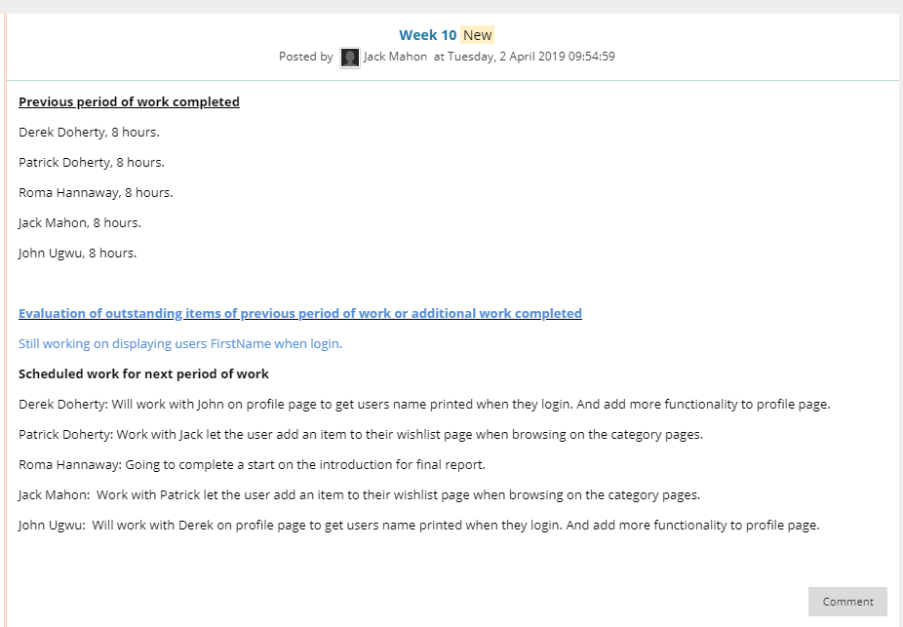

Figure

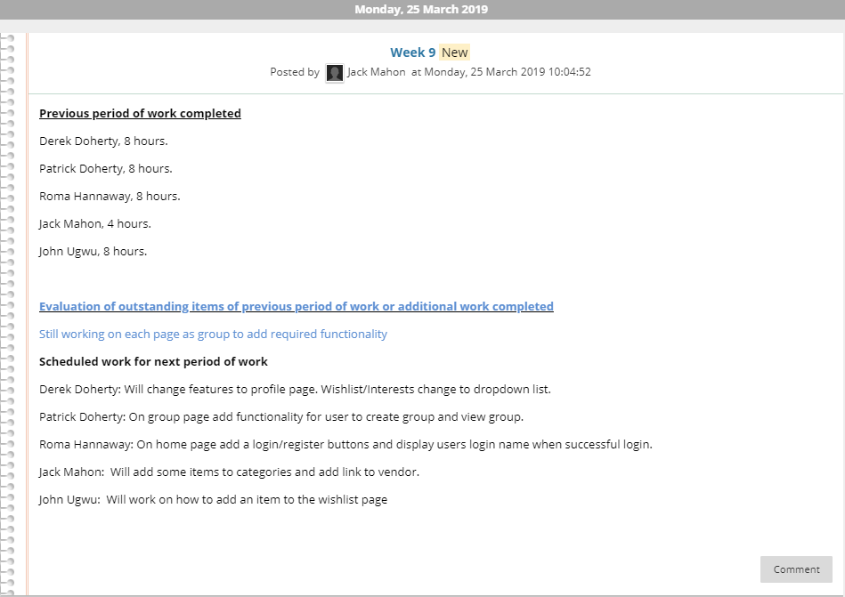

Figure

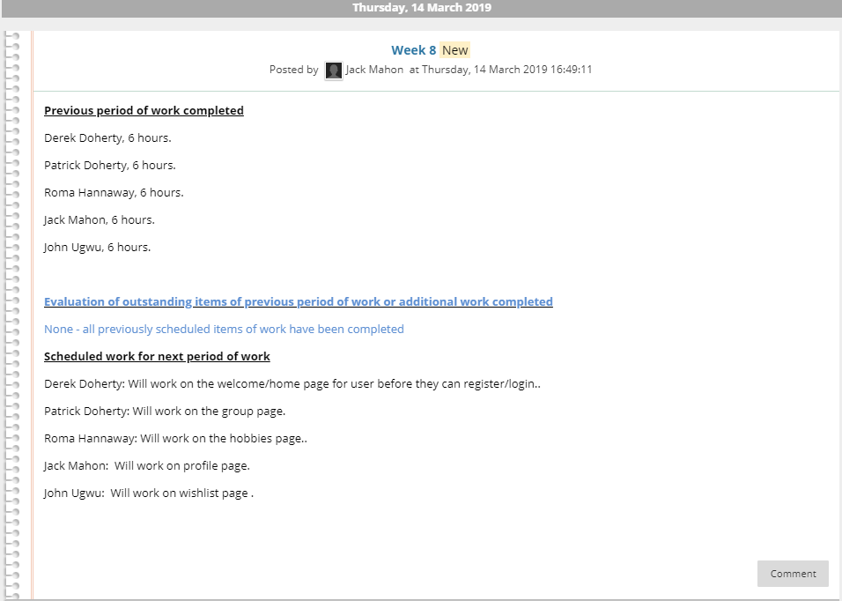

Figure

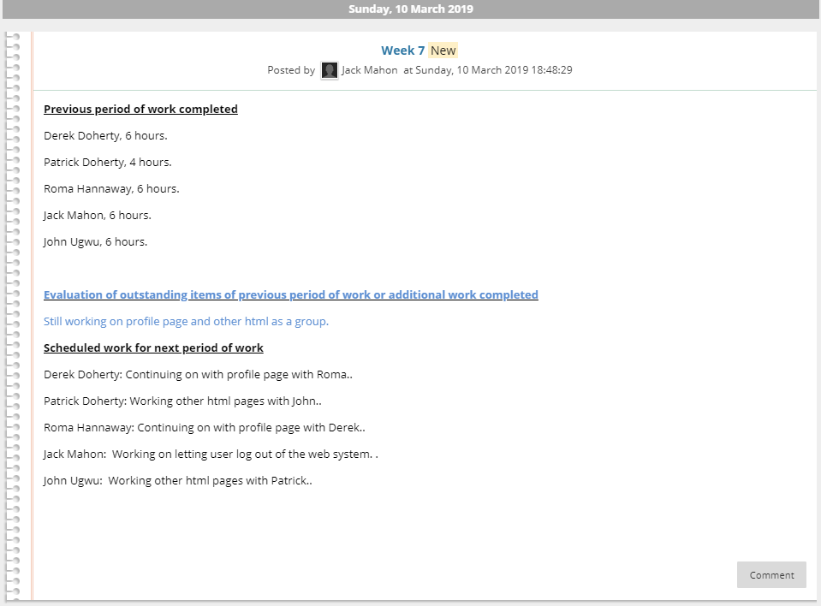

Figure

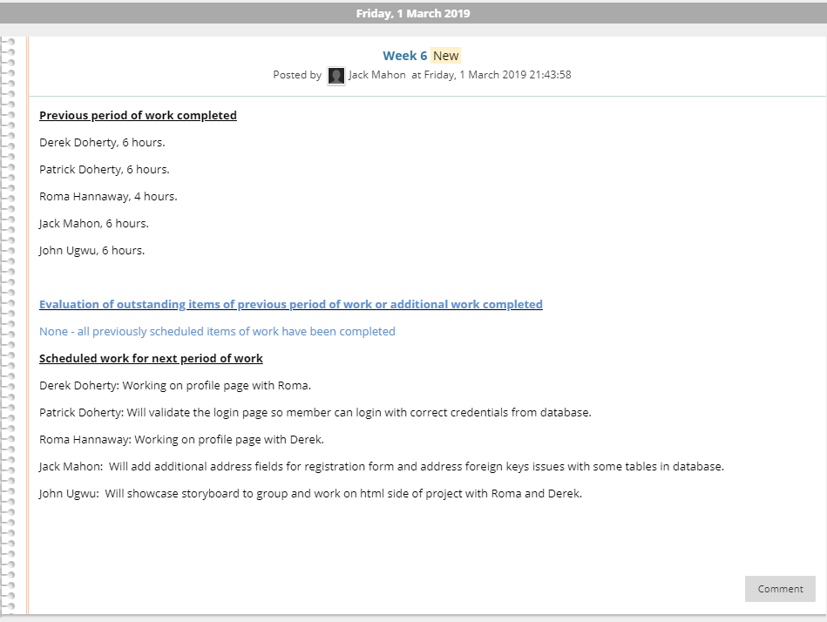

Figure

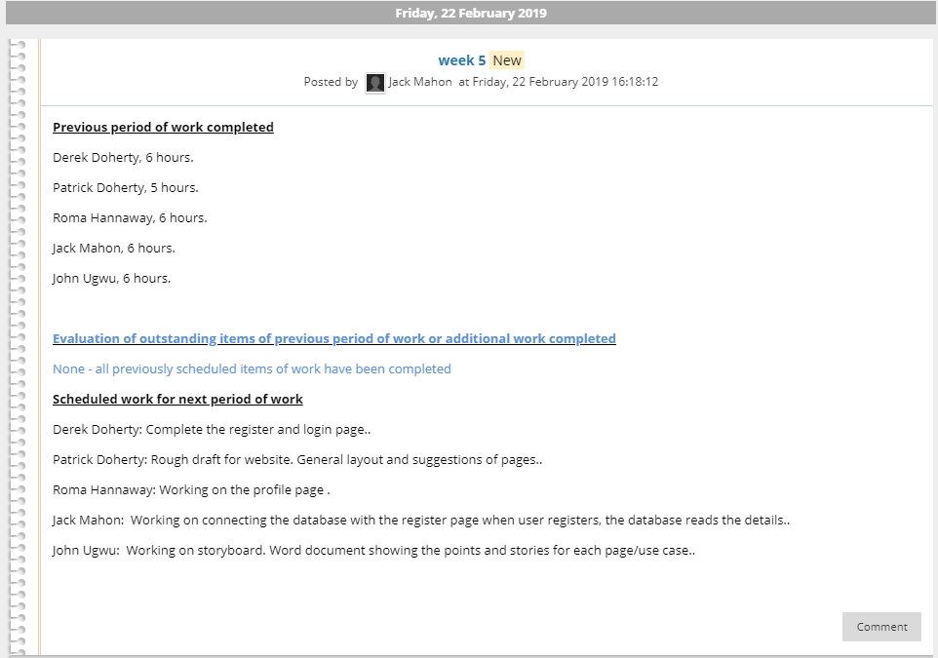

Figure

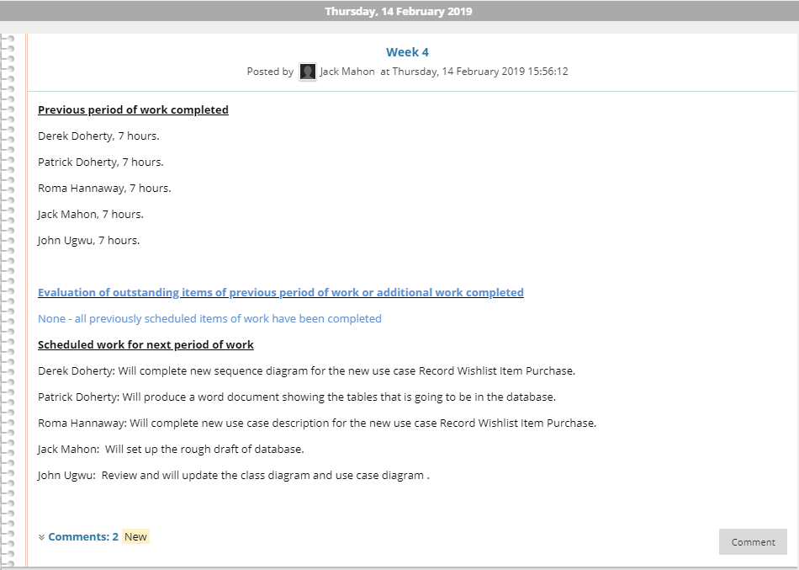

Figure

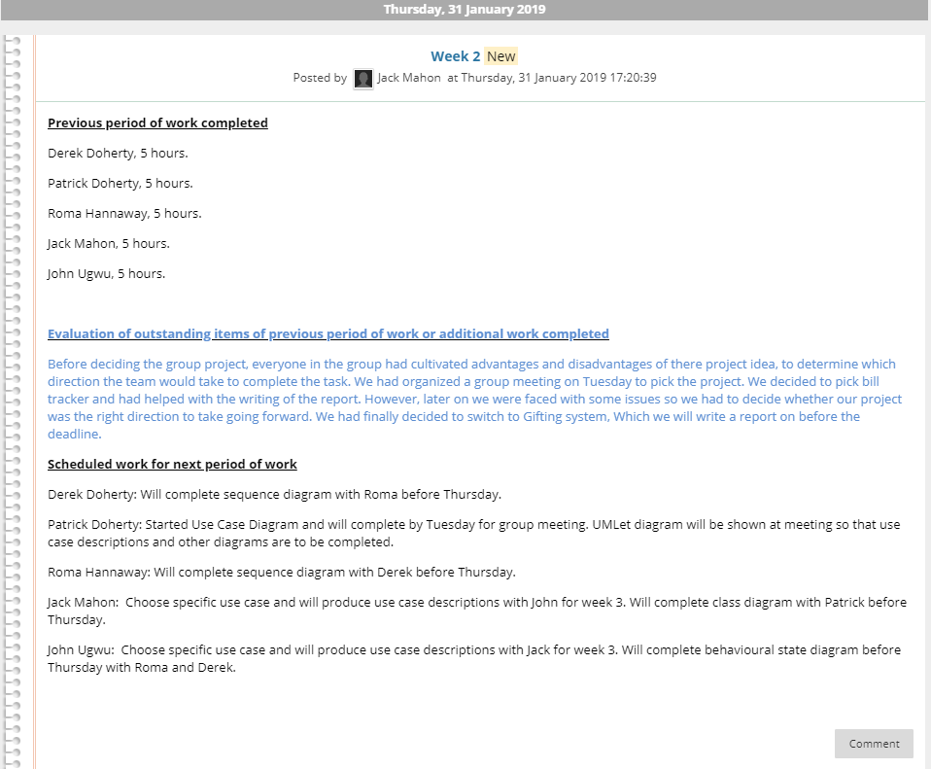

Figure